**These rules are to be followed, except in the situation where the hard copy is edited differently.**

**All Sections**

**NOTICE IS HEREBY GIVEN**

Is always caps and bold, no underline.   
‘THAT’ is always lowercase and usually roman. ‘that’ only remains bold if the entire paragraph is bold.

**IN THE MATTER OF**   
is always caps and bold, no underline.

City Planning Commission-  
see below-there is NO RULE above ‘BOROUGH OF QUEENS’ OR ‘BOROUGH OF MANHATTAN’

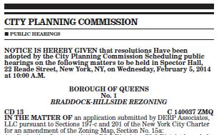

There are **NO** ‘DIVISIONS’ in the Table of Contents or the remainder of the paper WITH THE EXCEPTION of sections 2 and 4. Section 3 (Property Disposition) only get DIVISIONS if it is written on the hard copy

COMMUNITY BOARDS ads

BOROUGH OF QUEENS or any other borough should center and underlined. A thin rule after the date tag should separate one ad from the other

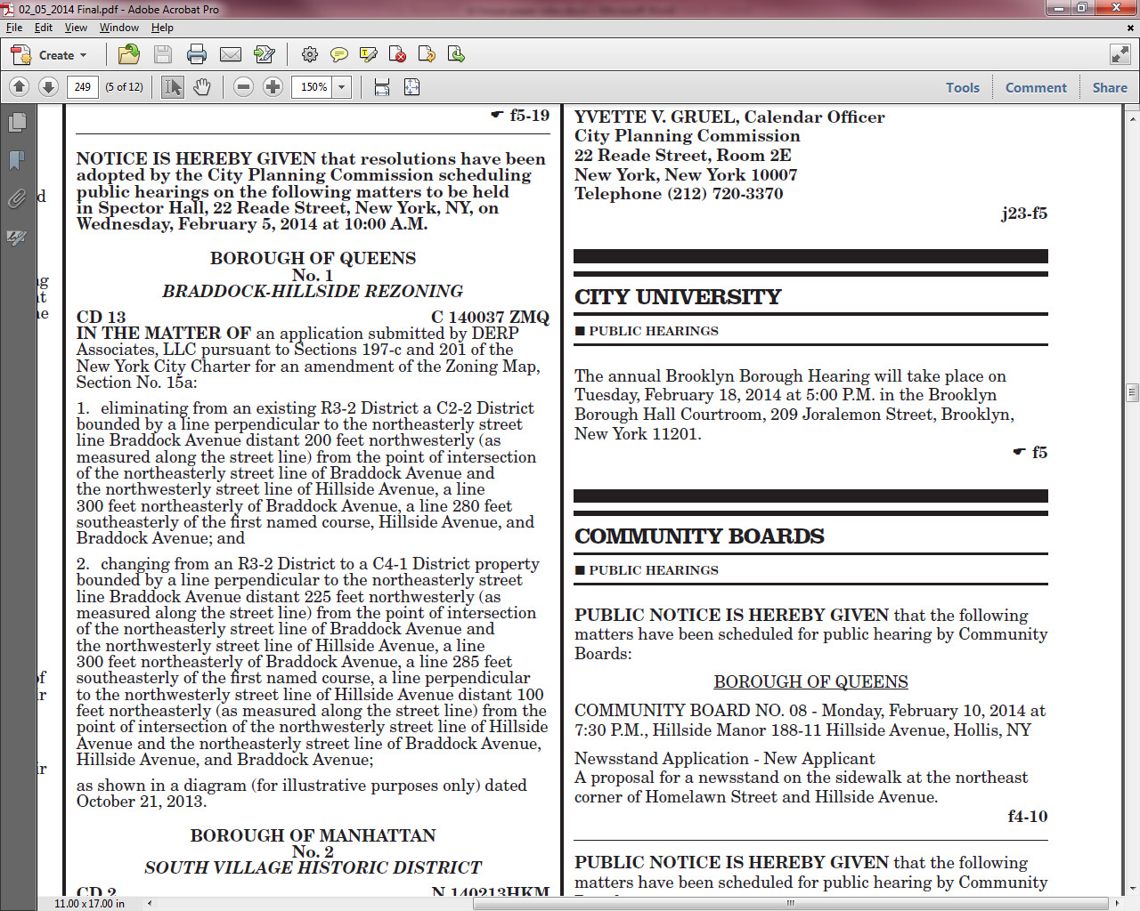

**A.M. and P.M.** should always appear (the entire paper) in caps and with the periods as shown.

Hyphens (-) are to be used throughout the paper, NOT EN DASH

PROCUREMENT: SECTION 4

All email addresses should be lowercase. In addition, in the footers-Names followed by a phone number should NOT have a semicolon after the contact person’s name.

I believe these issues may be able to be corrected via the system but in the meantime, keep an eye out.

FYI- see the PDF interactive document for styles (an ongoing effort, feel free to make suggestions).  
J:\CR_Print\Interactive doc

Any ad which runs with a cancellation notice e.g. “THIS PUBLIC HEARING HAS BEEN CANCELED”, the notice should be **CENTERED** and **BOLD** as shown below

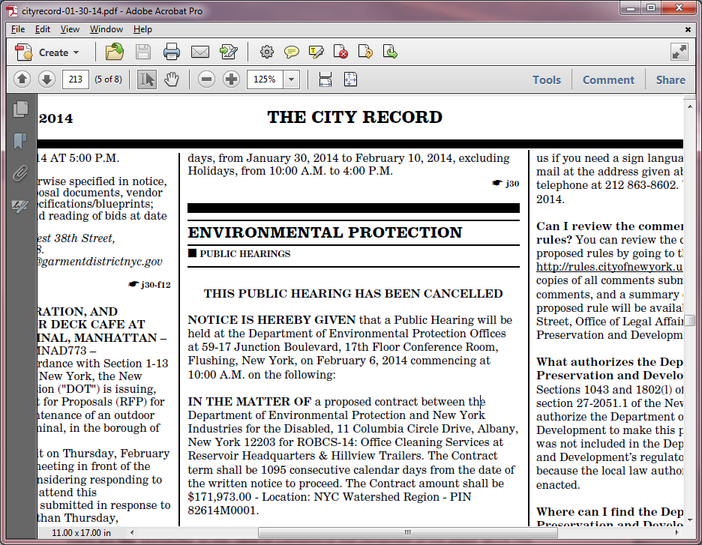

**SECTION 4 (Procurement)**

FOOTERS in Solicitations

Please follow the format below for section 4 footers

*Transportation, Office of the Agency Chief Contracting Officer, Contract Management Unit, 55 Water Street, Ground Floor, New York, NY 10041*. *Bid Window (212) 839-9435*

**This format is wrong, PLEASE DO NOT DO THIS**

*Transportation, New York City Department of Transportation, Office of the Agency Chief Contracting Officer, Contract Management Unit, 55 Water Street, Ground Floor, New York, NY 10041*. *Bid Window (212) 839-9435*

AWARDS

All Vendors and vendors’ addresses should be TITLE CASE

**e.g.**

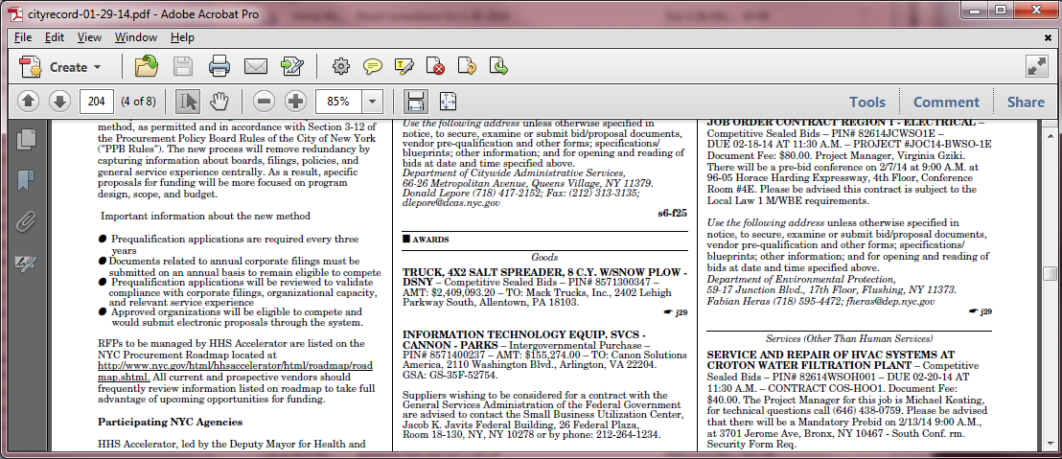

**Section 4A (Agency Public Hearing)**

**Please follow the format below when inputting ads with CONTRACTOR/ADDRESS. E-PIN/PIN, AMOUNT and BORO/CD**

**CORRECT FORMAT**

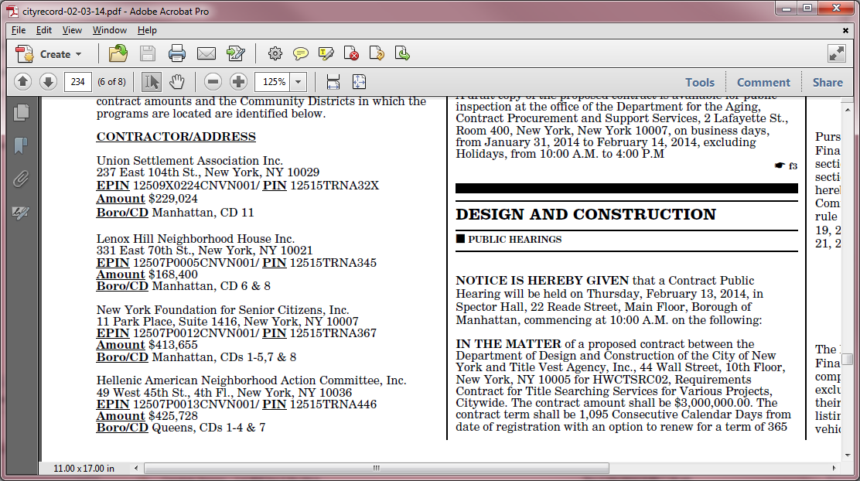

**WRONG FORMAT**

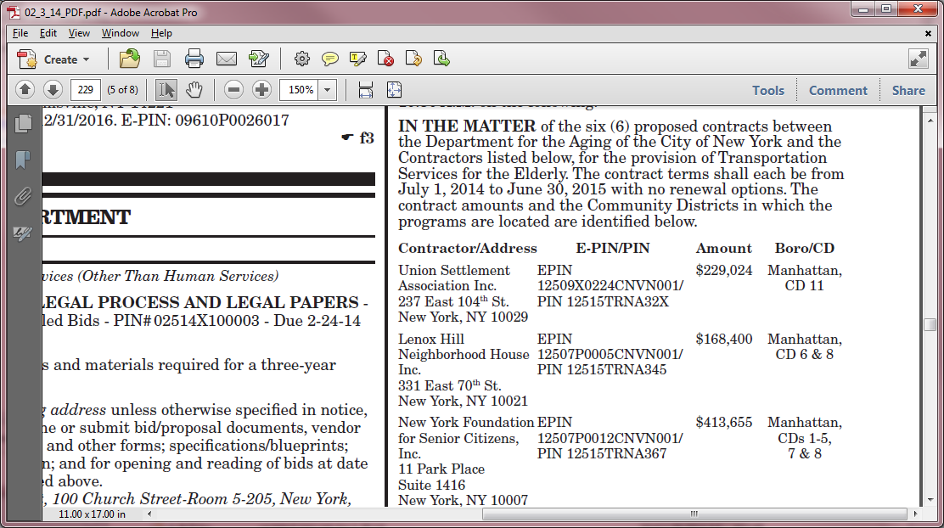

**When there is more than one ad under the same agency, each ad should be separated by a thin rule**

**CORRECT FORMAT WRONG FORMAT**

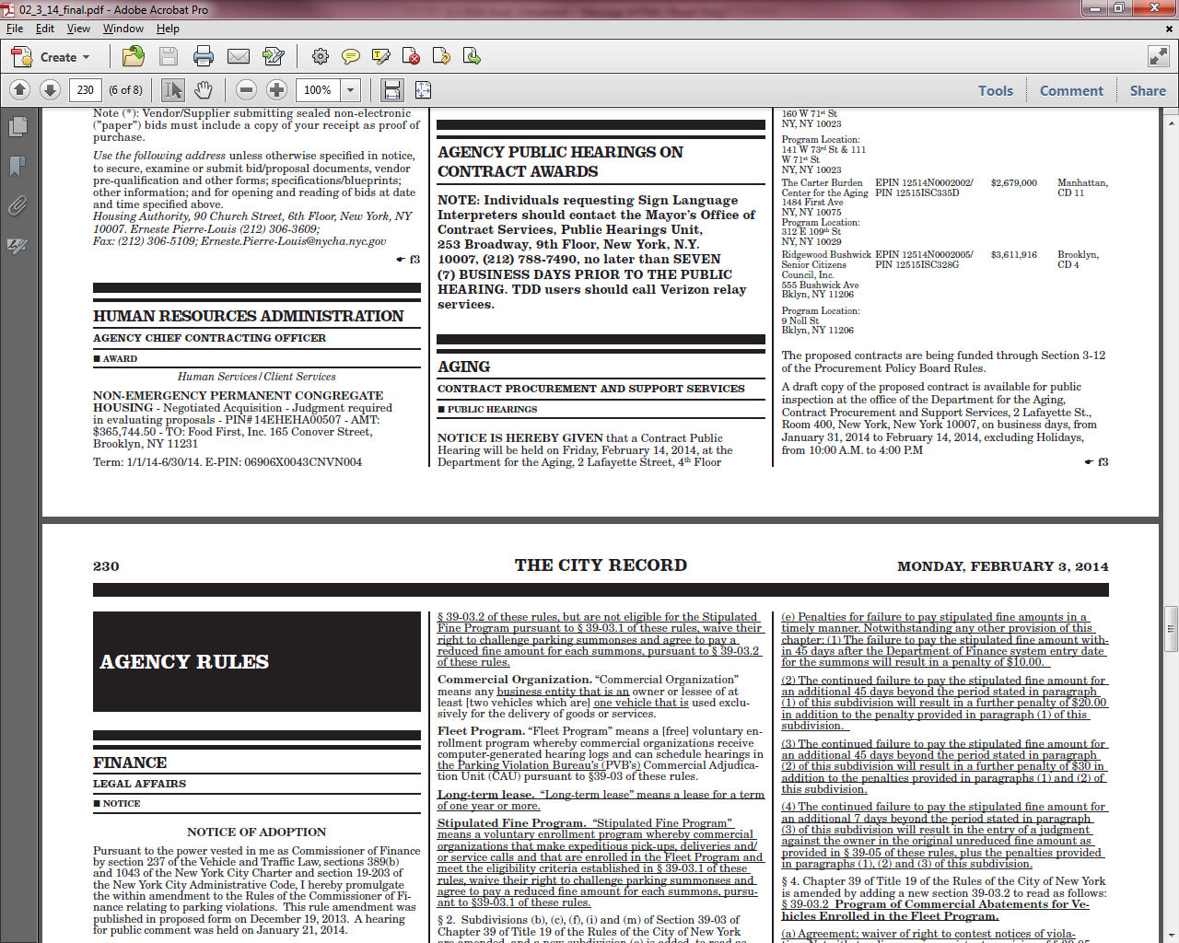 

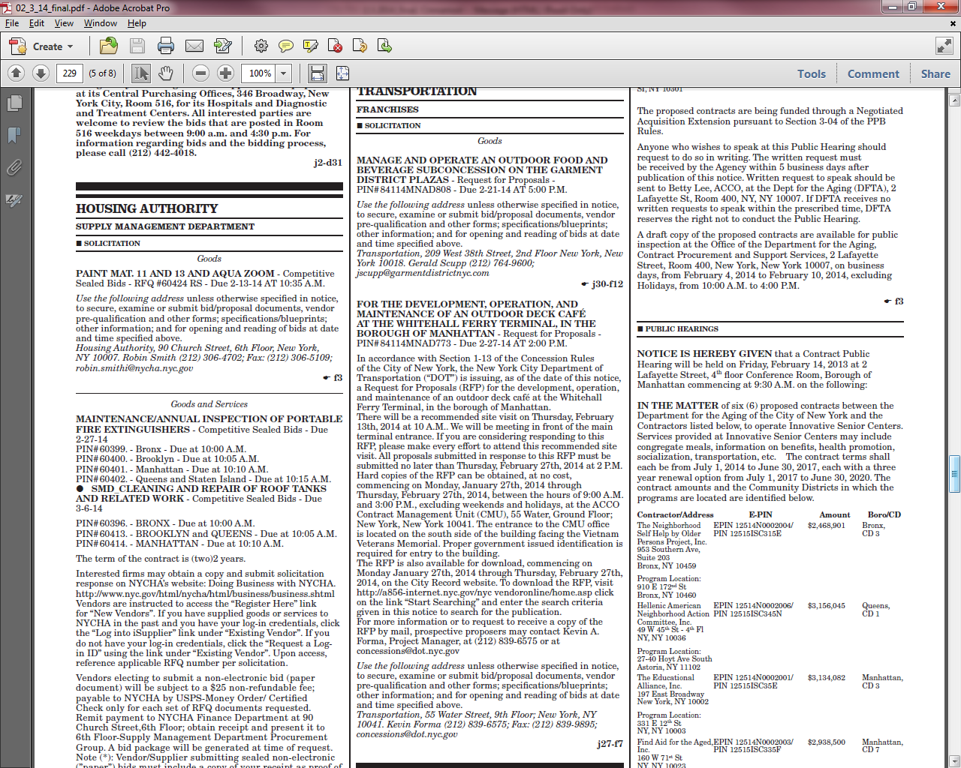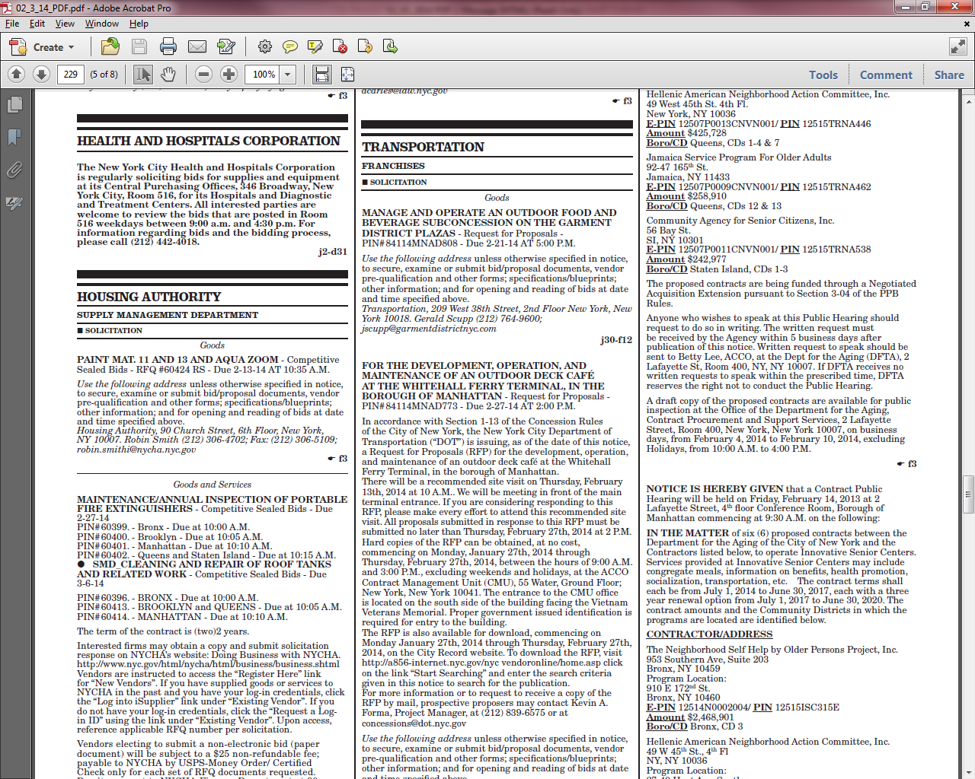

**LATE NOTICE SECTION**

Agency Public Hearing in the late notice section should always start with the follow

**AGENCY PUBLIC HEARINGS ON CONTRACT AWARDS**

**NOTE: Individuals requesting Sign Language Interpreters should contact**

**the Mayor’s Office of Contract Services, Public Hearings Unit,**

**253 Broadway, 9th Floor, New York, N.Y. 10007, (212) 788-7490, no later than**

**SEVEN (7) BUSINESS DAYS PRIOR TO THE PUBLIC HEARING. TDD users**

**should call Verizon relay services.**

**PLEASE PLEASE PLEASE**

Before sending your proof compare it to the previous paper, e.g. if you are working the 23rd, check the 22nd for corrections that may have been done.

Make corrections on the original document, therefore your co-worker can copy the corrected ad and the proofreader doesn’t have to make repeated corrections.